**Assignment** : JOIN LAB

**Name** : Pritesh Gandhi

1. List all the combinations of networks & the distributors.

Query :

CREATE OR REPLACE VIEW networkdistributorjoincross

AS

SELECT rn.*,rd.distr_name,rd.distr_loc

FROM rnetwork rn CROSS JOIN rdistributor rd;

Result :

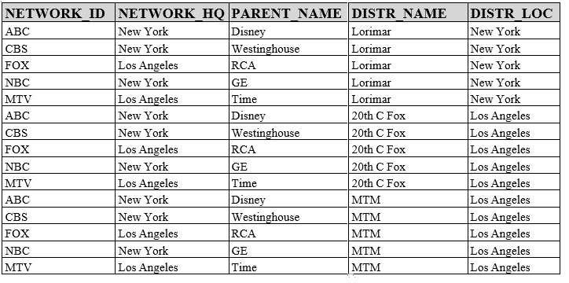

Cardinality: 15

1. List the details of all the networks & all the distributors if the distributor has the same parent as the network. Every distributor may not have a network with matching parent and every network may not have a distributor with the matching parent.

Query :

CREATE OR REPLACE VIEW networkdistributorjoinfull

AS

SELECT rn.*,rd.distr_name,rd.distr_loc,rd.parent_name dist_parent

FROM rnetwork rn FULL JOIN rdistributor rd

on rn.parent_name=rd.parent_name;

Result :

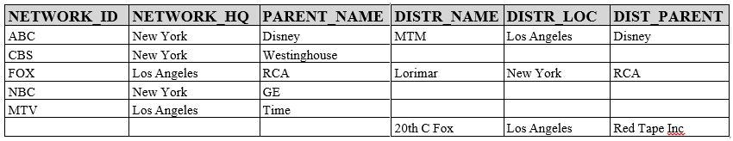

Cardinality: 6

1. Give the details of all the actors who have won any awards with the award details.

Query :

CREATE OR REPLACE VIEW awardwiningactorsjoinon

AS

SELECT ra.*,raa.award_name,raa.award_type,raa.award_year

FROM ractor ra INNER JOIN ractoraward raa

ON ra.actor_num=raa.actor_num;

Cardinality: 28

1. Give the details of all the actors who have won any awards with the award details.

(Don’t use Natural Join but remove duplicate columns)

Query :

CREATE OR REPLACE VIEW awardwiningactorsjoinusing

AS

SELECT *

FROM ractor ra INNER JOIN ractoraward raa

USING (actor_num);

Cardinality: 28

1. List the details of all the networks along with the distributor if the distributor has the same parent as the network. Every network may not have a distributor with the matching parent.

Query :

CREATE OR REPLACE VIEW networkdistributorjoinleft

AS

SELECT rn.*,rd.distr_name,rd.distr_loc

FROM rnetwork rn LEFT JOIN rdistributor rd

on rn.parent_name=rd.parent_name;

Result :

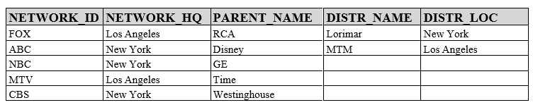

Cardinality: 5

1. Give the details of all the actor's who have won any awards. (Duplicate columns should not be displayed)

Query :

CREATE OR REPLACE VIEW awardwiningactorsjoinnatural

AS

SELECT *

FROM ractor ra NATURAL JOIN ractoraward raa;

Cardinality: 28

1. List the details of all the distributors along with the network if the network has the same parent as the distributor. Every distributor may not have a network with matching parent.

Query:

CREATE OR REPLACE VIEW networkdistributorjoinright

AS

SELECT rn.*,rd.distr_name,rd.distr_loc

FROM rnetwork rn RIGHT JOIN rdistributor rd

on rn.parent_name=rd.parent_name;

Result :

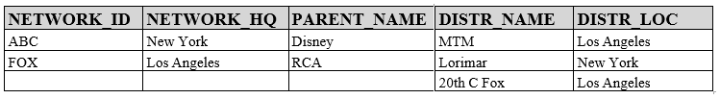

Cardinality: 3